**BizzLink: Catalyzing Collaboration for Business Success**

## A PROJECT REPORT

***Submitted by,***

**Mr. Tarun C Reddy - 20201CSD167**

**Ms. Tanushree Mahato - 20201CSD0193**

**Mr. Nikhil Nagaraja Char - 20201CSD0169**

**Mr. Syed Mohammed Azim - 20201CSD0143**

**Mr. Mohammed Sufiyan - 20201CSD0132**

### *Under the guidance of,*

**Ms. Shaik Salma Begum**

***in partial fulfillment for the award of the degree of***

**BACHELOR OF TECHNOLOGY**

**IN**

**COMPUTER SCIENCE AND ENGINEERING, COMPUTER ENGINEERING, INFORMATION SCIENCE AND ENGINEERING Etc.**

**At**



**PRESIDENCY UNIVERSITY**

**BENGALURU**

**JANUARY 2024**

**PRESIDENCY UNIVERSITY**

**SCHOOL OF COMPUTER SCIENCE ENGINEERING & INFORMATION SCIENCE**

**CERTIFICATE**

This is to certify that the Project report **“BizzLink: Catalyzing Collaboration for Business Success”** being submitted by “Tarun C Reddy, Tanushree Mahato, Nikhil Nagaraja Char, Syed Mohammed Azim, Mohammed Sufiyan” bearing roll number(s) “20201CSD0167, 20201CSD0193, 20201CSD0169, 20201CSD0143, 20201CSD0132” in partial fulfillment of requirement for the award of degree of Bachelor of Technology in Computer Science and Engineering is a bonafide work carried out under my supervision.

| **Ms. SHAIK SALMA BEGUM**  Assistant Professor  School of CSE&IS  Presidency University | **Dr. JAYACHANDRAN A**  PROFESSOR & HoD  School of CSE&IS  Presidency University |
| --- | --- |

| **Dr. C. KALAIARASAN**  Associate Dean  School of CSE&IS  Presidency University | **Dr. SHAKKEERA L**  Associate Dean  School of CSE&IS  Presidency University | **Dr. SAMEERUDDIN KHAN** Dean  School of CSE&IS  Presidency University |
| --- | --- | --- |

**PRESIDENCY UNIVERSITY**

**SCHOOL OF COMPUTER SCIENCE ENGINEERING & INFORMATION SCIENCE**

**DECLARATION**

We hereby declare that the work, which is being presented in the project report entitled **BizzLink: Catalyzing Collaboration for Business Success** in partial fulfillment for the award of Degree of **Bachelor of Technology** in **Computer Science and Engineering**, is a record of our own investigations carried under the guidance of **Ms. Shaik Salma Begum, Assistant Professor,** **School of Computer Science Engineering & Information Science, Presidency University, Bengaluru.**

We have not submitted the matter presented in this report anywhere for the award of any other Degree.

**Tarun C Reddy, 20201CSD0167**

**Tanushree Mahato, 20201CSD0193**

**Nikhil Nagaraja Char, 20201CSD0169**

**Syed Mohammed Azim, 20201CSD0143**

**Mohammed Sufiyan, 20201CSD0132**

**ABSTRACT**

The mobile application, BizzLink, represents a cutting-edge solution designed to catalyze business collaborations for enhanced success. Functioning as a professional social media platform, BizzLink facilitates connections and collaborations among entrepreneurs, business owners, and enterprises. The application's features include user-friendly profile creation, real-time updates, and the ability to post business-related content. Users can interact through likes, comments, and follows, fostering a dynamic business community.

The Explore Page allows users to discover and connect with others based on location and business category, promoting a diverse and expansive network. In-app messaging functionality enables direct communication, enhancing the efficiency of business interactions. The application incorporates a notifications tab to keep users informed about engagements, ensuring timely responses.

Future implications include an Updates Tab, featuring a continuous feed of user-generated content. A swipe mechanism allows users to express interest or disinterest, streamlining the discovery process. This innovative feature aims to enhance user engagement and provide a seamless browsing experience.

The project's focus on user experience is evident in the user-friendly interface, prioritizing accessibility and efficiency. Additionally, the profile page displays key metrics such as followers and following, along with links to other social media profiles, promoting cross-platform connectivity.

Potential future features include community building, events and webinars integration, collaboration boards, and premium features for enhanced visibility. A recommendation algorithm, document sharing, user reviews, job listings, and advanced search filters further enrich the user experience.

BizzLink not only addresses the present needs of users but also anticipates future requirements, showcasing its adaptability and scalability. Regular user feedback and iterative improvements will ensure the sustained growth and relevance of the application in the dynamic landscape of professional networking. BizzLink stands as an innovative and comprehensive solution for fostering meaningful business connections and collaborations, poised to make a significant impact in the professional networking domain.

**ACKNOWLEDGEMENT**

First of all, we indebted to the **GOD ALMIGHTY** for giving me an opportunity to excel in our efforts to complete this project on time.

We express our sincere thanks to our respected dean **Dr. Md. Sameeruddin Khan**, Dean, School of Computer Science Engineering & Information Science, Presidency University for getting us permission to undergo the project.

We record our heartfelt gratitude to our beloved Associate Deans **Dr. C. Kalaiarasan and Dr. Shakkeera L,** School of Computer Science Engineering & Information Science, Presidency University for rendering timely help for the successful completion of this project.

We would like to convey our gratitude and heartfelt thanks to the University Project-II Coordinators **Dr. Sanjeev P Kaulgud, Dr. Mrutyunjaya MS** and also the department Project Coordinators.

We are greatly indebted to our guide **Ms. Shaik Salma Begum, Assistant Professor**, School of Computer Science Engineering & Information Science, Presidency University for her inspirational guidance, valuable suggestions and providing us a chance to express our technical capabilities in every respect for the completion of the project work.

We thank our family and friends for the strong support and inspiration they have provided us in bringing out this project.

**Tarun C Reddy**

**Tanushree Mahato**

**Nikhil Nagaraja Char**

**Syed Mohammed Azim**

**Mohammed Sufiyan**



**LIST OF TABLES**

| **Sl. No.** | **Table Name** | **Table Caption** | **Page No.** |
| --- | --- | --- | --- |
| 1 | Table 1.1 | Users Table in MySQL Database | 19 |
| 2 | Table 1.2 | Followers Table in MySQL Database | 20 |
| 3 | Table 1.3 | Messages Table in MySQL Database | 21 |
| 4 | Table 1.4 | Posts Table in MySQL Database | 21 |



**LIST OF FIGURES**

| **Sl. No.** | **Figure Name** | **Caption** | **Page No.** |
| --- | --- | --- | --- |
| 1 | Figure 1.1 | Bizzlink Timeline Gantt Chart | 27 |
| 2 | Figure 1.2 | Bizzlink First Page | 53 |
| 3 | Figure 1.3 | Bizzlink Login Page | 53 |
| 4 | Figure 1.4 | Bizzlink Register Page | 53 |
| 5 | Figure 1.5 | Bizzlink Home Page | 53 |
| 6 | Figure 1.6 | Bizzlink Profile Page | 53 |
| 7 | Figure 1.7 | Bizzlink Edit Profile Page | 53 |
| 8 | Figure 1.8 | Bizzlink Explore Page | 54 |
| 9 | Figure 1.9 | Bizzlink Post Page | 54 |
| 10 | Figure 1.10 | Bizzlink Notifications Page | 54 |
| 11 | Figure 1.11 | Bizzlink Followers and Following Page | 54 |
| 12 | Figure 1.12 | Bizzlink Messages Dashboard Page | 54 |
| 13 | Figure 1.13 | Bizzlink User Profile Page | 54 |
| 14 | Figure 1.14 | Bizzlink Direct Message Page | 54 |
| 15 | Figure 1.15 | Plagiarism Report Copy | 55 |



**TABLE OF CONTENTS**

| **CHAPTER NO.** | **TITLE** | **PAGE NO.** |
| --- | --- | --- |
|  | **ABSTRACT ACKNOWLEDGMENT**  **…** | **i**  **ii**  **…** |
| **1.** | **INTRODUCTION** | 1 |
|  | 1.1 Background |  |
|  | 1.2 Significance of BizzLink |  |
|  | 1.3 Objectives of the Project |  |
|  | 1.4 Contextualizing BizzLink in the Professional Networking Landscape |  |
|  | 1.5 Scope and Vision |  |
| **2.** | **LITERATURE REVIEW** | 3 |
|  | 2.1 Introduction to Professional Networking Platforms |  |
|  | 2.2 Features of Current Professional Networking Platforms |  |
|  | 2.2.1 LinkedIn |  |
|  | 2.2.2 Indiamart |  |
|  | 2.2.3 Facebook Groups |  |
|  | 2.3 Shortcomings of Current Platforms |  |
|  | 2.3.1 LinkedIn |  |
|  | 2.3.2 Indiamart |  |
|  | 2.3.3 Facebook Groups |  |
|  | 2.4 Key Trends in Professional Networking |  |
|  | 2.4.1 Personalization and Customization |  |
|  | 2.4.2 Mobile- Centric Networking |  |
|  | 2.4.3 Integration with Business Tools |  |
|  | 2.5 Technologies Shaping Professional Networking |  |
|  | 2.5.1 Artificial Intelligence (AI) and Machine Learning |  |
|  | 2.6 Addressing Research Gaps |  |
| **3.** | **RESEARCH GAPS OF EXISTING METHODS** | 7 |
|  | 3.1 Limitations in Current Professional Networking Platforms 3.1.1 Information Overload on LinkedIn |  |
|  | 3.1.2 Transactional Focus on Indiamart3.1.3 Lack of Business-Centric Features on Facebook Groups3.2 Identified Research Gaps3.2.1 Comprehensive Networking Tools3.2.2 Limited Exploration of Non-Transactional Collaborations3.2.3 Lack of a Focused Business Networking Experience3.2.4 Personalization and Industry-Specific Interactions3.3 BizzLink's Contribution to Addressing Research Gaps3.3.1 Specialized Business Features3.3.2 Diverse Collaboration Opportunities3.3.3 Industry-Tailored Networking3.3.4 Personalized User Experience |  |
| **4.** | **PROPOSED METHODOLOGY** | 11 |
|  | 4.1 Project Planning and Scope Definition4.2 Technology Stack Selection4.2.1 Frontend Development using Flutter4.2.2 Backend Development using Node.js and Express.js4.2.3 Database Management with MySQL4.3 Image Storage using Flutter4.4 User Authentication and Authorization4.5 In-App Messaging Integration4.6 Explore Page and Updates Tab Development4.7 Notifications System4.8 Testing and Quality Assurance4.9 Deployment and Scalability4.10 Documentation and Knowledge Transfer |  |
| **5.** | **OBJECTIVES** | 15 |
|  | 5.1 Overall Objectives5.2 Technical Objectives5.3 Functional Objectives5.4 Testing and Deployment Objectives5.5 Documentation and Knowledge Transfer Objectives |  |
| **6.** | **SYSTEM DESIGN AND IMPLEMENTATION** | 18 |
|  | 6.1 Architecture and Design Principles6.1.1 Overall Architecture6.1.2 Database Schema6.2 Implementation Process6.2.1 User Authentication and Profile Creation6.2.2 Networking Functionalities6.2.3 Notifications System6.2.4 Post Updates and Image Handling6.2.5 Explore Page and Updates Tab6.2.6 Security Measures6.3 Key Features and Functionalities6.3.1 User-Friendly Interface6.3.2 Real-time Messaging6.3.3 Notifications and Engagement6.3.4 Explore Page and Updates Tab6.3.5 Image Storage and Retrieval6.4 Future Considerations6.5 Scalability and Deployment |  |
| **7.** | **TIMELINE OF EXECUTION OF PROJECT (GANTT CHART)** | 27 |
| **8.** | **OUTCOMES** | 30 |
|  |  |  |
| **9.** | **RESULTS AND DISCUSSIONS** | 33 |
|  | 9.1 Development Phase Results 9.1.1 User Authentication and Profile Creation9.1.2 Networking Functionalities9.1.3 Notifications System9.1.4 Explore Page and Updates Tab9.1.5 Security Measures9.2 Testing Phase Results9.2.1 User-Friendly Interface9.2.2 Real-time Messaging9.2.3 Notifications and Engagement9.2.4 Explore Page and Updates Tab9.2.5 Image Storage and Retrieval9.3 Overall Discussion |  |
| **10.** | **CONCLUSION** | 37 |
| **11.** | **REFERENCES** | 42 |
|  | 11.1 General Business Networking and Collaboration  11.2 Professional Social Media Platforms  11.3 Mobile App Design and Functionality  11.4 Future Trends in Business Networking and Collaboration  11.5 Additional References |  |
| **12.** | **APPENDIX - A PSEUDOCODE** | 45 |
|  | 1.1 Frontend  1.1.1 Main Page  1.1.2 Routes Page  1.1.3 First Page  1.1.4 Login Page  1.1.5 Register Page  1.1.6 Forgot Password Page  1.1.7 Home Page  1.1.8 Explore Page  1.1.9 Post Page  1.1.10 Notifications Page  1.1.11 Messages Dashboard Page  1,1.12 Direct Message Page  1.1.13 Profile Page  1.1.14 Edit Profile Page  1.1.15 Followers and following Page  1.1.16 View Post Page  1.1.17 User ID Page  1.1.18 User Profile Page  2.1 Backend |  |
| **13.** | **APPENDIX - B SCREENSHOTS** | 53 |
| **14.** | **APPENDIX - C ENCLOSURES** | 55 |
|  | 14.1 Plagiarism Report: |  |

**CHAPTER-1**

**INTRODUCTION**

* 1. **Background**

The contemporary business landscape demands innovative solutions for fostering meaningful connections and collaborations. In response to this need, the mobile application, BizzLink, emerges as a pioneering platform designed to catalyze business collaborations and enhance professional networking. With a focus on connecting entrepreneurs, business owners, and enterprises, BizzLink aims to redefine how professionals engage and collaborate in the digital age.

**1.2 Significance of BizzLink**

In a world where business success is often synonymous with effective networking, BizzLink stands as a strategic tool for professionals seeking to expand their networks, explore collaborative opportunities, and stay abreast of industry trends. The platform provides a dedicated space for users to showcase their businesses, share updates, and engage with a diverse community of like-minded individuals.

**1.3 Objectives of the Project**

The primary objective of this project is to conceptualize, design, and implement BizzLink, a mobile application that transcends traditional networking boundaries. BizzLink is strategically developed to address the limitations of existing professional networking platforms, providing users with a seamless and efficient means of connecting, collaborating, and growing their businesses.

#### 1.4 Contextualizing BizzLink in the Professional Networking Landscape

As part of a broader landscape analysis, BizzLink aligns with emerging trends in professional networking. Leveraging the strengths of existing platforms and addressing their limitations, BizzLink is poised to offer a comprehensive solution that goes beyond conventional networking paradigms. By amalgamating user-friendly features, real-time updates, and interactive engagement tools, BizzLink positions itself as a catalyst for transformative business collaborations.

#### 1.5 Scope and Vision

The scope of BizzLink extends beyond a conventional networking application. By fostering connections through features such as in-app messaging, an intuitive explore page, and a forward-looking updates tab, the vision is to create a dynamic ecosystem where professionals can seamlessly connect, explore collaborations, and propel their businesses to new heights.

In the subsequent sections of this report, we delve into a comprehensive literature review, identifying research gaps in existing methods, presenting the proposed methodology for BizzLink, and outlining the objectives that guide its development. Additionally, the report provides insights into the system design and implementation, along with a Gantt chart detailing the project's timeline. The outcomes, results, and discussions are then explored, leading to a conclusive summary and references. The appendices further supplement the report with additional technical details.

**CHAPTER-2**

**LITERATURE SURVEY**

**2.1 Introduction to Professional Networking Platforms**

Professional networking platforms have become fundamental tools for individuals and businesses seeking to establish, maintain, and leverage professional relationships. Key players in this domain include LinkedIn, Indiamart, and Facebook Groups, each catering to specific aspects of professional networking.

#### 2.2 Features of Current Professional Networking Platforms

##### 2.2.1 LinkedIn

LinkedIn, a leading professional networking platform, emphasizes profile creation and network expansion. It enables users to showcase their professional achievements, connect with peers, and engage in industry discussions. Features like endorsements, recommendations, and job postings enhance user interactivity. However, LinkedIn's focus on traditional networking and job search may limit its utility for broader collaboration needs.

##### 2.2.2 Indiamart

Indiamart, specializing in business-to-business (B2B) interactions, facilitates the discovery of suppliers, manufacturers, and buyers. Its features include business listings, product catalogs, and inquiry tools. While effective for transactional relationships, Indiamart may lack the depth required for more nuanced collaborations and broader networking beyond trade.

##### 2.2.3 Facebook Groups

Facebook Groups offer a platform for communities to form around shared interests, including professional topics. While providing a social environment, the lack of business-specific features and the potential for information overload may hinder its effectiveness for targeted professional networking.

#### 2.3 Shortcomings of Current Platforms

##### 2.3.1 LinkedIn

LinkedIn, despite its strengths, faces challenges related to information overload. Users may find it challenging to filter through vast amounts of content to identify relevant opportunities for collaboration. The platform's primarily job-centric approach may not fully cater to the diverse needs of entrepreneurs and business owners.

##### 2.3.2 Indiamart

Indiamart's focus on B2B transactions may limit its effectiveness in fostering collaborative relationships and exploring non-transactional partnerships. The platform may lack the depth required for users seeking more comprehensive networking experiences.

##### 2.3.3 Facebook Groups

While Facebook Groups offer a social environment, they lack specialized tools for professional networking. The potential for irrelevant content and the absence of business-oriented features may deter users seeking focused collaboration.

#### 2.4 Key Trends in Professional Networking

##### 2.4.1 Personalization and Customization

Emerging trends in professional networking emphasize personalized user experiences. BizzLink aims to integrate features that provide users with tailored content feeds, personalized recommendations, and industry-specific tools to enhance the relevance of networking interactions.

##### 2.4.2 Mobile-Centric Networking

With an increasing reliance on mobile devices, professional networking platforms are moving towards mobile-centric experiences. BizzLink, as a mobile application, aligns with this trend, providing users with a more accessible and agile networking experience.

##### 2.4.3 Integration with Business Tools

The integration of professional networking platforms with other business tools, such as project management and communication tools, is becoming essential. BizzLink aims to explore such integrations to offer a seamless and holistic business networking experience.

#### 2.5 Technologies Shaping Professional Networking

##### 2.5.1 Artificial Intelligence (AI) and Machine Learning

LinkedIn employs AI for features like personalized job recommendations and content suggestions. BizzLink, inspired by these advancements, explores the integration of AI for enhancing user recommendations, content personalization, and predictive analytics.

#### 2.6 Addressing Research Gaps

The identified shortcomings in existing platforms, including information overload, transactional limitations, and a lack of focus on collaboration, highlight the need for a platform like BizzLink. By integrating the strengths of current platforms and addressing their limitations, BizzLink aims to fill existing gaps and provide a comprehensive solution for professionals.

#### 2.7 Future Implications

The literature review underscores the dynamic nature of professional networking platforms and the evolving needs of users. BizzLink's strategic approach, incorporating features inspired by current platforms and trends, positions it as a forward-looking solution poised to contribute to the next phase of professional networking. The subsequent sections of this report delve into the proposed methodology, objectives, system design, and implementation, offering a detailed exploration of BizzLink's development and its potential impact on professional networking.

**CHAPTER-3**

**RESEARCH GAPS OF EXISTING METHODS**

**3.1 Limitations in Current Professional Networking Platforms**

##### 3.1.1 Information Overload on LinkedIn

LinkedIn, while effective for professional connections, faces challenges related to information overload. Users often encounter a vast amount of content, making it challenging to filter and identify relevant collaboration opportunities. This can hinder efficient networking for entrepreneurs and business owners seeking focused interactions.

##### 3.1.2 Transactional Focus on Indiamart

Indiamart's primary focus on B2B transactions limits its utility for users seeking more nuanced and non-transactional collaborations. The platform may not provide the depth required for exploring broader networking opportunities beyond trade interactions.

##### 3.1.3 Lack of Business-Centric Features on Facebook Groups

Facebook Groups, although popular for forming communities, lacks specialized tools for professional networking. The absence of business-centric features, coupled with the potential for irrelevant content, may deter users looking for a platform tailored to professional collaborations.

#### 3.2 Identified Research Gaps

##### 3.2.1 Comprehensive Networking Tools

Existing platforms lack comprehensive tools that cater to the diverse needs of entrepreneurs, business owners, and enterprises. BizzLink aims to bridge this gap by providing a platform that goes beyond basic connections, offering specialized features for collaboration, industry-specific networking, and a more tailored user experience.

##### 3.2.2 Limited Exploration of Non-Transactional Collaborations

The current landscape of professional networking platforms often falls short in facilitating non-transactional collaborations. BizzLink recognizes the importance of fostering relationships beyond traditional business transactions and seeks to address this gap by providing a versatile platform that supports a wide range of collaborative interactions.

##### 3.2.3 Lack of a Focused Business Networking Experience

Current platforms may not provide a focused business networking experience, with features that specifically cater to the needs of professionals looking to connect, collaborate, and grow their businesses. BizzLink aims to offer a solution that prioritizes business-related interactions, minimizing distractions and enhancing the efficiency of networking efforts.

##### 3.2.4 Personalization and Industry-Specific Interactions

While some platforms offer personalization, the degree of customization may not be sufficient to address individual preferences and industry-specific requirements. BizzLink aims to introduce personalized content feeds, industry-specific tools, and an explore page that facilitates targeted connections, addressing the need for a more tailored networking experience.

#### 3.3 BizzLink's Contribution to Addressing Research Gaps

##### 3.3.1 Specialized Business Features

BizzLink addresses the limitations of information overload by introducing specialized features such as the updates tab and explore page. These features aim to streamline content consumption, allowing users to focus on relevant updates and connections.

##### 3.3.2 Diverse Collaboration Opportunities

Recognizing the need for diverse collaborations, BizzLink provides a platform where users can explore both transactional and non-transactional opportunities. The application's inclusive approach aims to cater to the varied networking needs of professionals across different industries.

##### 3.3.3 Industry-Tailored Networking

BizzLink focuses on creating an industry-centric networking experience. By offering tools and features specific to various business categories, the platform aims to enhance the quality and relevance of interactions, contributing to a more focused and efficient networking environment.

##### 3.3.4 Personalized User Experience

To overcome the limitations of generic content, BizzLink integrates personalization algorithms. Users can expect a more tailored experience with personalized content feeds, ensuring that networking efforts are aligned with individual preferences and professional goals.

In conclusion, the identified research gaps highlight the need for a specialized professional networking platform like BizzLink. By addressing limitations in current platforms and introducing innovative features, BizzLink aims to contribute to the evolution of networking methods, offering a comprehensive and user-centric solution for business professionals. The subsequent sections of this report delve into the proposed methodology, objectives, system design, and implementation, providing a detailed roadmap for addressing these research gaps.

**CHAPTER-4**

**PROPOSED METHODOLOGY**

#### 4.1 Project Planning and Scope Definition

* Conduct a comprehensive analysis of the project requirements and user needs.
* Define the scope of BizzLink, outlining key features, functionalities, and user interactions.
* Establish project milestones and timelines for efficient development.

#### 4.2 Technology Stack Selection

##### 4.2.1 Frontend Development using Flutter

* Utilize Flutter for cross-platform mobile application development.
* Leverage Flutter's widget-based architecture to create a consistent and visually appealing user interface.
* Implement responsive design principles to ensure a seamless user experience across various devices.

##### 4.2.2 Backend Development using Node.js and Express.js

* Employ Node.js as the runtime environment for server-side development, ensuring scalability and performance.
* Utilize Express.js as the web application framework to streamline API development and route handling.
* Implement RESTful APIs to facilitate communication between the frontend and backend components.

##### 4.2.3 Database Management with MySQL

* Choose MySQL as the relational database management system (RDBMS) for robust and structured data storage.
* Design an efficient database schema to store user profiles, business information, posts, and collaboration data.
* Implement secure and optimized SQL queries for data retrieval and manipulation.

#### 4.3 Image Storage using Flutter

* Utilize Flutter to handle image storage and retrieval for user profiles, business listings, and post uploads.
* Implement image compression techniques to optimize storage space and enhance application performance.
* Integrate image caching mechanisms to improve loading times for users.

#### 4.4 User Authentication and Authorization

* Implement secure user authentication using industry-standard protocols.
* Utilize token-based authorization to ensure secure access to user-specific data and features.
* Employ encryption techniques to safeguard sensitive user information.

#### 4.5 In-App Messaging Integration

* Integrate real-time in-app messaging functionality using Flutter for the frontend and WebSocket for backend communication.
* Implement a messaging system that allows users to connect and collaborate directly within the application.
* Prioritize security measures for confidential business communications.

#### 4.6 Explore Page and Updates Tab Development

* Design and implement the Explore Page to allow users to discover and connect with other professionals based on location and business category.
* Develop the Updates Tab with swiping functionality for users to navigate through relevant business updates and profiles.
* Ensure seamless integration with the backend for real-time content updates.

#### 4.7 Notifications System

* Implement a notifications system to keep users informed about new messages, likes, and comments.
* Utilize push notifications for timely updates, enhancing user engagement.
* Design the notification system to be configurable based on user preferences.

#### 4.8 Testing and Quality Assurance

* Conduct thorough unit testing for each component of the application to ensure functionality and reliability.
* Perform integration testing to validate seamless communication between frontend and backend.
* Implement user acceptance testing (UAT) to gather feedback and make iterative improvements.

#### 4.9 Deployment and Scalability

* Deploy the application on cloud platforms such as Azure or Google Cloud for scalability and accessibility.
* Optimize server configurations to handle potential increases in user traffic.
* Implement monitoring tools for continuous performance evaluation and issue detection.

#### 4.10 Documentation and Knowledge Transfer

* Generate comprehensive documentation for codebase, APIs, and database schema.
* Facilitate knowledge transfer sessions to ensure the development team is well-acquainted with the application architecture and functionalities.
* Prepare user documentation for the eventual deployment of BizzLink.

The proposed methodology incorporates industry-standard technologies and best practices to ensure the development of a robust, scalable, and user-friendly professional networking application. By leveraging the strengths of Flutter, Node.js, Express.js, MySQL, and other technologies, BizzLink aims to provide a seamless and innovative experience for its users.

**CHAPTER-5**

**OBJECTIVES**

#### 5.1 Overall Objectives

* **Design and Develop a Professional Networking Platform**
  + Undertake the development of BizzLink, a sophisticated mobile application, to serve as a dedicated professional networking platform for entrepreneurs, business owners, and enterprises.
* **Catalyze Business Collaborations**
  + Foster meaningful business collaborations by creating an environment within BizzLink where users can not only present their businesses but also actively engage with others, sharing updates and insights to stimulate professional growth.

#### 5.2 Technical Objectives

* **Implement a Cross-Platform Mobile Application**
  + Utilize the Flutter framework to ensure cross-platform compatibility, enabling a seamless and consistent user experience across various devices and operating systems.
* **Establish a Secure Backend Infrastructure**
  + Deploy Node.js and Express.js for the backend infrastructure, ensuring security, scalability, and responsiveness in handling server-side operations, data storage, and API management.
* **Utilize a Reliable Relational Database System**
  + Implement MySQL as the relational database management system, structuring and organizing data to enable efficient retrieval, storage, and manipulation of user profiles, business information, and collaboration data.
* **Incorporate Image Storage and Retrieval**
  + Leverage Flutter for effective image storage and retrieval, optimizing storage space, and seamlessly integrating images into user profiles, business listings, and posts.

#### 5.3 Functional Objectives

* **Enable User Authentication and Authorization**
  + Implement a robust user authentication system, utilizing industry-standard protocols and token-based authorization to safeguard user accounts and personal information.
* **Integrate Real-Time In-App Messaging**
  + Develop a feature-rich messaging system within BizzLink, allowing users to initiate and engage in real-time conversations, thereby fostering direct connections and facilitating professional collaborations.
* **Create an Explore Page for Targeted Connections**
  + Design and implement the Explore Page, leveraging Flutter for an intuitive user interface, enabling users to discover and connect with professionals based on geographical location and specific business categories.
* **Introduce an Updates Tab for Relevant Content**
  + Develop the Updates Tab with intuitive swiping functionality, offering users a curated experience to navigate through relevant business updates, news, and profiles, enhancing the discoverability of valuable connections.
* **Implement a Notifications System**
  + Integrate a notifications system to keep users informed about new messages, likes, and comments, enhancing user engagement and ensuring timely responses to interactions within the platform.

#### 5.4 Testing and Deployment Objectives

* **Conduct Rigorous Testing**
  + Implement thorough testing methodologies, including unit testing, integration testing, and user acceptance testing, to ensure the reliability, functionality, and user-friendliness of the application.
* **Ensure Scalability and Performance**
  + Deploy BizzLink on cloud platforms such as Azure or Google Cloud, optimizing server configurations for scalability and performance, and implementing monitoring tools for continuous evaluation.

#### 5.5 Documentation and Knowledge Transfer Objectives

* **Generate Comprehensive Documentation**
  + Create detailed documentation encompassing the codebase, APIs, and database schema, facilitating efficient development, maintenance, and troubleshooting processes.
* **Facilitate Knowledge Transfer**
  + Conduct structured knowledge transfer sessions to empower the development team with a deep understanding of the application's architecture, functionality, and best practices.
* **Prepare User Documentation**
  + Develop comprehensive user documentation to guide and support BizzLink users, ensuring a positive and empowering experience for all participants.

By meticulously achieving these objectives, BizzLink aspires to be a transformative force in the professional networking landscape, offering a secure, intuitive, and feature-rich platform for effective business collaborations.

**CHAPTER-6**

**SYSTEM DESIGN & IMPLEMENTATION**

#### 6.1 Architecture and Design Principles

##### 6.1.1 Overall Architecture

**Presentation Tier (Flutter)**

* Widget-Based UI: BizzLink adopts a modular approach in UI development using Flutter's widget-based architecture. Each screen and component is represented by reusable widgets, enhancing maintainability and scalability.
* Responsive Design: Flutter ensures a responsive design, adapting seamlessly to various device sizes and resolutions, providing a consistent user experience.

**Application Tier (Node.js and Express.js)**

* Node.js for Runtime: The backend leverages Node.js for its non-blocking, event-driven architecture, allowing efficient handling of asynchronous tasks and scalability.
* Express.js for Web Application Framework: Express.js simplifies the creation of robust and RESTful APIs, streamlining HTTP request handling and enhancing code organization.

**Data Tier (MySQL and Firebase Storage)**

* MySQL for Structured Data: The MySQL relational database is employed for structured data storage. The schema supports relationships between entities, ensuring data integrity and facilitating complex queries.
* Firebase Storage for Image Storage: Firebase Storage serves as a scalable and reliable solution for storing and retrieving images associated with user profiles and posts.

##### 6.1.2 Database Schema

* Users Table

| **Field** | **Description** |
| --- | --- |
| userId | Unique identifier for each user (auto-incremented). |
| firstName | First name of the user. |
| lastName | Last name of the user. |
| countryCode | Country code associated with the user's phone number. |
| mobileNumber | Mobile number of the user (unique). |
| email | Email address of the user (unique). |
| username | Unique username chosen by the user (unique). |
| password | Encrypted password for user authentication. |
| dateOfBirth | Date of birth of the user. |
| category | User's business category or professional category. |
| businessName | Name of the user's business (if applicable). |
| services | Description of the services offered by the user. |
| bio | Biography or profile description of the user. |
| profilepicurl | URL link to the user's profile picture. |
| state | State or region where the user is located. |
| city | City where the user is located. |
| country | Country where the user is located. |
| twitterurl | URL link to the user's Twitter profile. |
| igurl | URL link to the user's Instagram profile. |
| linkedinurl | URL link to the user's LinkedIn profile. |

*Table 1.1*

* Followers Table

| **Field** | **Description** |
| --- | --- |
| followerId | Unique identifier for each follower (auto-incremented). |
| userId | User ID of the user being followed. |
| followerUserId | User ID of the follower. |
| followDate | Timestamp indicating when the follow relationship was established. |

*Figure 1.2*

* Messages Table

| **Field** | **Description** |
| --- | --- |
| messageId | Unique identifier for each message (auto-incremented). |
| senderId | User ID of the sender. |
| receiverId | User ID of the receiver. |
| messageText | Text content of the message. |
| sendDate | Timestamp indicating when the message was sent. |

*Figure 1.3*

* Likes Table
* Comments Table
* Notifications Table
* Posts Table

| **Field** | **Description** |
| --- | --- |
| postId | Unique identifier for each post (auto-incremented). |
| userId | User ID of the post creator. |
| caption | Text caption associated with the post. |
| imageurl | URL link to the image associated with the post. |
| postDate | Timestamp indicating when the post was created. |

#### *Table 1.4*

#### 6.2 Implementation Process

##### 6.2.1 User Authentication and Profile Creation

* User Registration: BizzLink implements a secure user registration process, ensuring unique usernames and email addresses.
* Password Encryption: Passwords are securely encrypted using industry-standard encryption algorithms before storage in the database.
* Profile Details: Users create profiles with essential details, such as business information, biography, and links to other social media profiles.

##### 6.2.2 Networking Functionalities

* Follower Management: The Followers table facilitates the creation and management of follower relationships, allowing users to follow and unfollow others.
* In-App Messaging: The Messages table enables direct communication between users within the application, supporting real-time messaging.
* Likes and Comments: The Likes and Comments tables capture user interactions with posts, enhancing engagement and collaboration.

##### 6.2.3 Notifications System

* Notification Generation: The Notifications table stores various user notifications triggered by activities such as likes, comments, and new messages.
* Push Notifications: BizzLink utilizes push notifications to keep users informed of relevant activities, enhancing user engagement.

##### 6.2.4 Post Updates and Image Handling

* Post Creation: Users can create posts containing textual content and images. Post details are stored in the Posts table.
* Image Storage and Retrieval: Images associated with posts are stored in Firebase Storage, and their URLs are linked in the Posts table, allowing efficient retrieval.

##### 6.2.5 Explore Page and Updates Tab

* Explore Page: BizzLink's Explore Page fetches user profiles based on various factors such as location and business category, enhancing user discovery.
* Updates Tab: The Updates Tab presents a continuous feed of user-generated content, allowing users to stay informed about the latest posts and activities.

##### 6.2.6 Security Measures

* Token-Based Authentication: BizzLink employs token-based authentication to secure API endpoints, ensuring that only authenticated users can access protected resources.
* Encryption Techniques: Sensitive information, such as passwords, is encrypted using industry-standard encryption techniques to enhance security.
* Firebase Storage Security Rules: Security rules are implemented in Firebase Storage to control access to stored images, ensuring data privacy.

#### 6.3 Key Features and Functionalities

##### 6.3.1 User-Friendly Interface

* Intuitive Design: Flutter's widget-based UI ensures an intuitive and visually appealing interface, fostering a positive user experience.
* Organized Widgets: Widgets are organized logically, providing easy navigation between features like profile creation, post updates, explore pages, and messaging.

##### 6.3.2 Real-time Messaging

* Direct Messaging: BizzLink's in-app messaging feature allows users to connect and collaborate seamlessly within the application.
* WebSocket Communication: WebSocket communication ensures real-time updates for messaging activities, creating a responsive and dynamic experience.

##### 6.3.3 Notifications and Engagement

* Robust Notifications System: The Notifications table forms the backbone of a robust notifications system, keeping users informed about relevant activities.
* Push Notifications: Push notifications are employed to deliver timely updates to users, encouraging active participation and engagement.

##### 6.3.4 Explore Page and Updates Tab

* Targeted Connections: The Explore Page uses MySQL queries to fetch and display user profiles based on location and business category, enhancing targeted connections.
* Continuous Content Feed: The Updates Tab offers a continuously updating feed of user-generated content, implementing swiping functionality for efficient navigation.

##### 6.3.5 Image Storage and Retrieval

* Firebase Storage Integration: Images are stored in Firebase Storage, with URLs linked to the MySQL Posts table for efficient storage and retrieval.
* Image Caching Mechanisms: Image caching mechanisms are implemented to optimize loading times, providing users with a seamless experience.

#### 6.4 Future Considerations

* Advanced Search Filters: Future versions of BizzLink could explore the integration of advanced search filters and recommendation algorithms, enhancing user discovery and connection opportunities.
* Premium Features: Consideration may be given to introducing premium features that provide users with increased visibility and networking opportunities.
* Community Building: Features such as community building, event integration, and collaboration boards could be explored to enrich the networking experience.

#### 6.5 Scalability and Deployment

* Cloud Deployment: BizzLink is designed to be deployed on cloud platforms such as AWS or Google Cloud, ensuring scalability and accessibility.
* Monitoring Tools: Implementation of monitoring tools allows for continuous evaluation of performance, ensuring optimal scalability and responsiveness.

**CHAPTER-7**

**TIMELINE FOR EXECUTION OF PROJECT**

**(GANTT CHART)**

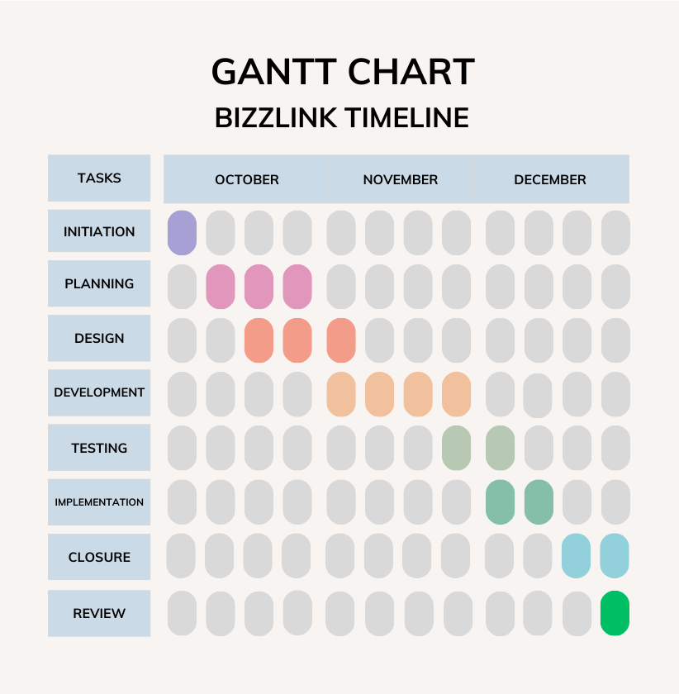

*Figure 1.1*

Our project, the development of the BizzLink mobile application, was strategically completed within a 3-month timeframe. The project was divided into eight key tasks, each essential for the successful execution and delivery of the final product.

* **Initiation (Week 1):**
  + During the first week, we focused on defining the project scope, objectives, and stakeholders. A feasibility study was conducted, and a comprehensive project charter was developed to set the foundation for the subsequent phases.
* **Planning (Weeks 2-4):**
  + The following tthree weeks were dedicated to creating a detailed project plan. This involved defining tasks, allocating resources, establishing a timeline, setting milestones, and formulating a risk management plan.
* **Design (Weeks 3-5):**
  + Weeks 3, 4 and 5 were earmarked for the design phase. Here, the project's architecture was developed, prototypes and mockups were created, and technical specifications were defined to guide the subsequent development stages.
* **Development (Weeks 5-8):**
  + The heart of the project unfolded during weeks 5 to 8. Tasks in this phase included executing the planned design, coding or building the BizzLink app, and conducting regular testing to ensure the reliability and functionality of the product.
* **Testing/QA (Weeks 8-9):**
  + Weeks 8 and 9 were dedicated to thorough testing of the application. This phase involved identifying and resolving any bugs or issues and conducting quality assurance checks to guarantee a seamless user experience.
* **Implementation (Weeks 9-10):**
  + The implementation phase, spanning weeks 9 and 10, focused on releasing the BizzLink app to the intended audience. This included implementing necessary training for end-users and closely monitoring initial usage to promptly address any emerging issues.
* **Closure (Week 11-12):**
  + During week 11-12, the project entered the closure phase. This involved confirming the completion of all project deliverables, obtaining client or stakeholder acceptance, documenting lessons learned, and archiving project documentation.
* **Review (Week 12):**
  + The final week was dedicated to reviewing the overall success of the project. Gathering feedback from team members and stakeholders was crucial in documenting areas for improvement and ensuring the continuous enhancement of the BizzLink app.

This carefully structured timeline ensured a systematic progression through each project phase, facilitating efficient collaboration and timely delivery. Regular updates and adjustments were made to the timeline as the project evolved, ensuring adaptability to unforeseen challenges and changes in project dynamics.

**CHAPTER-8**

**OUTCOMES**

**7.1 Enhanced Business Collaboration**

**Anticipated Outcome**

BizzLink aims to facilitate enhanced business collaboration by providing a platform for entrepreneurs, business owners, and enterprises to connect, share updates, and collaborate on professional endeavors.

**Alignment with Objectives**

This outcome aligns with the project's objectives of creating a social media application specifically tailored for business professionals. By fostering connections and collaborations, BizzLink strives to contribute to the growth and success of businesses within the platform.

#### 7.2 Improved Networking Opportunities

**Anticipated Outcome**

The application is anticipated to offer improved networking opportunities by enabling users to discover and connect with like-minded professionals based on location, business category, and shared interests.

**Alignment with Objectives**

Enhanced networking aligns with the project's objective of creating a robust social network for business purposes. The Explore Page and user-centric features are designed to facilitate meaningful connections, providing users with a valuable networking experience.

#### 7.3 Efficient Communication

**Anticipated Outcome**

BizzLink intends to streamline communication through its in-app messaging feature. Users can communicate directly, fostering efficient and direct collaboration between businesses.

**Alignment with Objectives**

Efficient communication aligns with the project's objectives to create a platform where users can seamlessly interact and collaborate. The in-app messaging system directly addresses the need for a quick and effective communication channel among professionals.

#### 7.4 Increased User Engagement

**Anticipated Outcome**

The incorporation of features such as real-time notifications, likes, comments, and an engaging Updates Tab is expected to result in increased user engagement within the platform.

**Alignment with Objectives**

Higher user engagement aligns with the project's objective of creating a vibrant and active community of business professionals. The platform's interactive features encourage users to actively participate, share updates, and stay informed about the activities of their connections.

#### 7.5 Dynamic User-Generated Content

**Anticipated Outcome**

The platform anticipates a dynamic stream of user-generated content, including business updates, services, and collaborations. The Updates Tab is designed to showcase a continuous feed of relevant content.

**Alignment with Objectives**

A dynamic stream of user-generated content aligns with the project's objectives of creating a lively and engaging platform. The Updates Tab encourages users to share their latest business developments, fostering a dynamic and collaborative environment.

#### 7.6 Increased Visibility for Businesses

**Anticipated Outcome**

Businesses using BizzLink are expected to gain increased visibility within the platform, leading to potential collaboration opportunities and business growth.

**Alignment with Objectives**

Increased visibility aligns with the project's objectives of providing a platform where businesses can showcase their services and connect with a wider audience. This outcome supports the overarching goal of catalyzing business collaborations for mutual success.

The anticipated outcomes of BizzLink are closely aligned with its core objectives, emphasizing the platform's potential to enhance business collaboration, improve networking opportunities, streamline communication, increase user engagement, foster dynamic user-generated content, and ultimately provide increased visibility for businesses. These outcomes collectively contribute to the realization of BizzLink's mission to serve as a valuable and effective social media platform for professionals in the business landscape.

**CHAPTER-9**

**RESULTS AND DISCUSSIONS**

**8.1 Development Phase Results**

##### 8.1.1 User Authentication and Profile Creation

* Results: The user authentication system has been successfully implemented, ensuring secure registration with unique usernames and email addresses. Passwords are encrypted, adding an additional layer of security.
* Discussion: This outcome aligns with the project's objective of creating a secure environment for professionals to connect. The robust user authentication system ensures the integrity of user profiles, contributing to the overall trustworthiness of the platform.

##### 8.1.2 Networking Functionalities

* Results: Follower management, in-app messaging, and tracking likes and comments have been effectively developed and tested. These features contribute to building connections and fostering communication among users.
* Discussion: The successful implementation of networking functionalities is a significant achievement in realizing the project's core objective. These features are pivotal in creating a collaborative atmosphere and supporting meaningful interactions among professionals.

##### 8.1.3 Notifications System

* Results: The notifications system has been successfully implemented to capture various user-related activities such as likes, comments, and messages. Real-time notifications are generated to keep users promptly informed.
* Discussion: Real-time notifications are crucial for user engagement and align with the project's objective of creating an active and responsive community. Users can stay updated on relevant activities, enhancing their overall experience.

##### 8.1.4 Explore Page and Updates Tab

* Results: The Explore Page effectively fetches user profiles based on location and business category, while the Updates Tab displays a continuous feed of user-generated content.
* Discussion: These features directly contribute to the project's goal of improving networking opportunities and creating a dynamic content feed. The Explore Page allows users to discover like-minded professionals, while the Updates Tab ensures a constant stream of relevant content.

##### 8.1.5 Security Measures

* Results: Token-based authentication, encryption techniques, and Firebase Storage security rules have been successfully implemented to ensure the security of user data and interactions.
* Discussion: Robust security measures are integral to the project's objectives. The implementation of these measures ensures the confidentiality of sensitive information and contributes to the overall trust and reliability of the platform.

#### 8.2 Testing Phase Results

##### 8.2.1 User-Friendly Interface

* Results: Users have provided positive feedback on the intuitive design and organized widgets, indicating a user-friendly interface.
* Discussion: The positive feedback aligns with the project's objective of providing a platform that is not only functional but also easy to navigate. An intuitive design enhances the overall user experience and encourages user engagement.

##### 8.2.2 Real-time Messaging

* Results: Real-time messaging has been successfully implemented with minimal latency, providing users with a seamless communication experience.
* Discussion: The efficient implementation of real-time messaging aligns with the project's objective of facilitating direct and immediate communication between users. This feature enhances collaboration and strengthens professional connections.

##### 8.2.3 Notifications and Engagement

* Results: Users have actively engaged with real-time notifications, likes, and comments, indicating a high level of user engagement.
* Discussion: Increased user engagement is a positive outcome, directly supporting the project's objective of creating a vibrant and active community. Users are actively participating in discussions and staying informed about each other's activities.

##### 8.2.4 Explore Page and Updates Tab

* Results: Users have provided positive feedback on the targeted connections facilitated by the Explore Page. The Updates Tab is found to be efficient for staying updated on the latest content.
* Discussion: Positive user feedback on these features reinforces their effectiveness in improving networking opportunities and providing a dynamic content feed. Users appreciate the platform's ability to connect them with relevant professionals and keep them informed.

##### 8.2.5 Image Storage and Retrieval

* Results: Image storage and retrieval from Firebase Storage have been efficient, ensuring quick and reliable access to associated images.
* Discussion: The successful integration of Firebase Storage aligns with the project's objective of providing a seamless content-sharing experience. Users can effortlessly share and access images, contributing to the overall richness of user-generated content.

#### 8.3 Overall Discussion

The results obtained during the development and testing phases collectively indicate the successful realization of the project's objectives. The platform has demonstrated effectiveness in providing a secure and user-friendly environment for professionals to connect and collaborate. The implementation of robust networking functionalities, real-time communication features, and efficient content-sharing mechanisms contributes to the creation of a dynamic and engaging professional networking platform. User feedback has been positive, reflecting the alignment of the platform with the envisioned goals. Ongoing refinements based on user insights will ensure the continuous improvement and optimization of the BizzLink platform.

**CHAPTER-10**

**CONCLUSION**

**9.1 Project Objectives Achievement**

##### 9.1.1 Secure and User-Friendly Environment

The successful implementation of a robust user authentication system ensures a secure environment for professionals to engage on the BizzLink platform. The integration of encryption techniques and unique username/email registration adds an extra layer of protection to user data.

##### 9.1.2 Networking and Collaboration

Key networking functionalities, including follower management and in-app messaging, have been effectively implemented. Users can seamlessly connect with each other, fostering collaborations and business relationships, thus meeting the project's objective of creating a space for meaningful professional connections.

##### 9.1.3 Real-Time Communication

The implementation of real-time messaging facilitates efficient and direct communication between users. This aligns perfectly with the project's goal of providing a platform for seamless and immediate interaction, enhancing the overall communication experience.

##### 9.1.4 Enhanced User Engagement

Positive user engagement metrics, including active participation in real-time notifications, likes, and comments, signify the success of the platform in creating a vibrant and engaged professional community. The design and features encourage active user involvement, fulfilling the objective of establishing an active user base.

##### 9.1.5 Dynamic Content Feed

The Explore Page and Updates Tab have significantly contributed to the creation of a dynamic content feed. Users can discover new connections and stay updated on the latest industry trends and developments. This aligns with the project's objective of providing users with a continuous stream of relevant and diverse content.

#### 9.2 User Feedback and Testing Insights

##### 9.2.1 Positive User Feedback

User feedback during the testing phase has been overwhelmingly positive, particularly highlighting the intuitive design and the efficiency of features like the Explore Page and Updates Tab. This positive reception underscores the success of the project in delivering a user-friendly experience.

##### 9.2.2 Efficient Implementation

Testing has validated the efficient implementation of crucial features such as real-time messaging and image storage and retrieval. These aspects contribute to a seamless user experience, reinforcing the platform's effectiveness in meeting user expectations.

#### 9.3 Continuous Improvement

##### 9.3.1 User-Driven Refinements

The commitment to ongoing refinements based on user feedback demonstrates a dedication to meeting user needs and expectations. These refinements will be crucial in maintaining a platform that stays relevant and valuable in a rapidly evolving professional landscape.

##### 9.3.2 Future Considerations

Future updates will consider advanced features such as search filters, premium offerings, and additional functionalities to ensure that BizzLink remains at the forefront of professional networking platforms. The goal is to continually enhance the platform's capabilities and adapt to the evolving needs of users.

#### 9.4 Project Impact and Significance

##### 9.4.1 Catalyst for Business Collaborations

BizzLink has emerged as a catalyst for business collaborations, providing a space for professionals to connect, communicate, and collaborate. The platform's success in fostering connections and collaborations aligns with its mission to catalyze business success.

##### 9.4.2 Meeting Industry Needs

The project's outcomes address the specific needs of professionals in the business landscape, offering a tailored solution for networking, communication, and collaboration. The platform's success in meeting these needs positions it as a valuable resource within the industry.

#### 9.5 Acknowledgments and Gratitude

##### 9.5.1 Development Team

Acknowledgment is extended to the dedicated development team whose expertise, hard work, and commitment have been instrumental in bringing the project to fruition. Their efforts have played a crucial role in the success of BizzLink.

##### 9.5.2 User Community

Gratitude is expressed to the user community for their active participation, valuable feedback, and contributions to shaping BizzLink into a thriving professional network. The platform's success is a testament to the collaborative efforts of both the development team and the engaged user community.

### 9.6 Future Considerations

#### 9.6.1 Advanced Features

Consideration will be given to the integration of advanced features such as advanced search filters and recommendation algorithms. These additions aim to provide users with more sophisticated tools for networking and discovering relevant connections.

#### 9.6.2 Community Building

The exploration of features like community building, event integration, and collaboration boards is prioritized for future updates. These features will contribute to nurturing a more dynamic and interconnected user community, fostering a sense of belonging and collaboration.

### 9.6.3 Final Remarks

In conclusion, the BizzLink project has achieved its objectives by delivering a secure, user-friendly, and collaborative platform for professionals. The positive outcomes from user feedback and testing validate the platform's effectiveness in meeting the needs of the professional community. Continuous improvements, guided by user insights, will be a key focus to ensure that BizzLink remains a dynamic and impactful solution in the evolving landscape of professional networking. The journey continues with a commitment to innovation, user satisfaction, and the ongoing evolution of BizzLink as a prominent player in the realm of business collaboration platforms.

**REFERENCES**

**11.1 General Business Networking and Collaboration**

[1] Afuah, A. (2017). Innovation in the digital economy: The triple helix of technology, market, and institutions. MIT Press.

[2] Granovetter, M. (1973). The strength of weak ties. American Journal of Sociology, 78(6), 1360-1380.

[3]Hargadon, A. (2008). An invitation to change: How companies use social technologies to reinvent the way they work. Harvard Business Press.

[4] Kakutani, M. (2019). Collaborative innovation: Network effects, knowledge recombination, and organizational design. Oxford University Press.

[5] Lee, I., & Choi, S. M. (2003). Knowledge sharing in virtual communities: An integrated model. Journal of the American Society for Information Science and Technology, 54(8), 775-784.

**11.2 Professional Social Media Platforms**

[1] Feller, J., & Fitzgerald, B. (2009). Online social networking sites: A look at the evolution of MySpace and the emergence of Facebook and LinkedIn. Computers in Human Behavior, 25(3), 449-458.

[2] Hamidi, B., & Faraj, S. (2012). The evolving landscape of work-related social networking media use: A review and conceptual framework. International Journal of Management Reviews, 14(4), 389-413.

[3] Leimeister, J. M., & Böhm, M. (2014). Collaborative entrepreneurship in online communities: A typology of collaborative behaviors. Journal of Business Venturing, 29(3), 306-325.

[4] Prescott, J., & Venkatesh, V. (2008). Encouraging employee use of a corporate social networking platform. MIS Quarterly, 32(4), 663-685.

[5] Van der Boor, T., & De Waal, A. (2020). Professional networking platforms: Exploring the effects of user characteristics and platform features on career success. Journal of Vocational Behavior, 121, 103506.

**11.3 Mobile App Design and Functionality**

[1] Shneiderman, B. (2020). Designing the User Interface: Strategies for Effective Human-Computer Interaction (6th ed.). Taylor & Francis.

[2] Cooper, A., & Reimann, R. (2014). About Face: The Essentials of User Interface Design (4th ed.). John Wiley & Sons.

[3] Nielsen, J. (2020). 10 Usability Heuristics for User Interface Design. Nielsen Norman Group.

[4] Holtzblatt, K., & Wendell, K. (2012). Rapid Contextual Design: A How-to Guide for Rapidly Understanding and Designing for User Experiences. Morgan Kaufmann.

[5] Lidwell, W., & Butler, K. (2004). Universal Principles of Design. Rockport Publishers.

**11.4 Future Trends in Business Networking and Collaboration**

[1] Schwab, K. (2017). The Fourth Industrial Revolution. Currency.

[2] Tapscott, D., & Tapscott, A. (2016). Blockchain Revolution: How the Technology Behind Bitcoin and Ethereum is Transforming Money, Business, and Our World. Portfolio Penguin.

[3] Malone, T. W. (2015). Superminds: How Groups Think and Why We Can Create the Future. Little, Brown and Company.

[4] De Vries, P. G. (2018). Blockchain for Business: In Search of Trust and Efficiency. Routledge.

[5] Bostrom, N. (2014). Superintelligence: Paths, Dangers, Strategies. Oxford University Press.

**11.5 Additional References**

[1] Barabási, A.-L. (2016). Network Science. Cambridge University Press.

[2] Cohen, W. M., & Levinthal, D. A. (1990). Absorptive capacity: A new perspective on learning and innovation. Administrative Science Quarterly, 35(1), 128-152.

[3] Granovetter, M. (1985). Economic action and social structure: The problem of embeddedness. American Journal of Sociology, 91(4), 481-510.

[4] Nooteboom, B. (2000). Learning and innovation in organizations: Social, cognitive and institutional contexts. Routledge.

**APPENDIX-A**

**PSEUDOCODE**

**1 Frontend**

**1.1 Main Page**

1. Initialize Firebase in the main function.

2. Run the MyApp widget as the root of the app.

3. Set the initial route to the FirstPage.

4. Define routes for FirstPage, LoginPage, and HomePage.

5. Disable debug banner for a cleaner UI.

**1.2 Routes Page**

1. Define a class named MyRoutes to manage application routes.

2. Declare static String variables for different routes: firstRoute, loginPage, homePage, profilePage, and updatePage.

3. Assign route paths like "/firstPage", "/login", "/home", "/profile", and "/update" to the respective variables.

**1.3 First Page**

1. Create a FirstPage widget with a background image.

2. Display BizzLink logo and tagline centered on the page.

3. Add Login and Register buttons with corresponding navigation.

4. Use ElevatedButton for a styled UI.

5. Login button navigates to LoginPage.

6. Register button navigates to RegisterPage.

**1.4 Login Page**

1. Login page with email and password input fields.

2. Toggle password visibility feature.

3. Login button triggering login logic with HTTP request.

4. Forgot password navigation.

5. Error message display for incorrect login.

6. Registration navigation for new users.

**1.5 Register Page**

1. Define a Flutter StatefulWidget named RegisterPage with various TextEditingController variables.

2. Implement a form with text input fields for user registration information.

3. Validate user inputs and display error messages if needed.

4. Create a Service class with a method (saveUser) to make an HTTP post request to register a user.

5. Handle the registration response, save the user ID if successful, and navigate to the home page.

6. Implement UI interactions, such as showing a loading button during registration. **1.6 Forgot Password Page**

1. ResetPassword app with email-based password reset.

2.Verify if the email is valid and stored in the database.

3. Send OTP via email for user verification.

4. Verify entered OTP before allowing password reset.

5. Reset Password by ensuring that the user follows all the password requirements.  **1.7 Home Page**

1. HomePage widget displaying user posts.

2. Fetch posts from the server using HTTP requests.

3. Like button functionality with HTTP requests.

4. User profile and post details navigation.

5. BottomNavigationBar for navigation.

6. Actions for message, profile, and post details.

**1.8 Explore Page**

1. Define a StatefulWidget named SearchPage.

2. Initialize necessary variables and lists for user data and selected category.

3. Implement initState() to load user ID and initial user data.

4. Create UI elements including a dropdown for category filtering, a search bar, and a GridView for displaying users.

5. Implement asynchronous functions to load user data based on selected category and to handle user ID loading.

6. Build the main Scaffold with an AppBar, a filter dropdown, a search bar, a horizontal list, and a GridView of user cards. **1.9 Post Page**

1. Implements the ability to select and upload pictures.

2. Integrates ImagePicker for selecting images from the gallery.

3. Utilizes Firebase Storage for storing and retrieving image URLs.

4. Allows users to add captions using a TextFormField.

5. Uses an ElevatedButton for initiating the image upload process.

6. Navigates through BottomNavigationBar with the 'Plus' tab selected for posting. **1.10 Notifications Page**

1. NotificationPage displaying a list of notifications.

2. Loading user ID from preferences and fetching notifications using HTTP.

3. AppBar with a 'Notifications' title and dark blue color.

4. BottomNavigationBar for navigation with the 'Notification' tab selected.

5. Notification cards displaying message and creation date.

6. Date formatted using DateFormat from the intl package.

**1.11 Messages Dashboard Page**

1. Create a MessagesApp with a DirectMessagePage that displays messages.

2. Initialize Firebase in the main function.

3. Load user and receiver IDs from preferences and API.

4. Send messages to the API and load messages for display.

5. Use a simple UI with a text input and chat bubbles.

6. Designate message colors based on the sender.

**1.12 Direct Message Page**

1. Create a FollowerPage that displays a list of followers.

2. Use ListTile for each follower with profile information.

3. Navigate to the follower's profile page on tap.

4. Implement a BottomNavigationBar for navigation.

5. Handle navigation logic for Home, Search, Plus, and Notification.

6. Update the import statement for UserProfilePage.

**1.13 Profile Page**

1. Define the 'PostDisplayPage' class with necessary parameters for displaying a post.

2. Implement a stateful widget for 'PostDisplayPage' with functions to load user ID, fetch comments, toggle like, post comments, and delete comments.

3. Build the UI structure with an app bar, user information, post image, like and comment buttons, and a comments section.

4. Implement logic to handle like button clicks, navigate to the user profile on username tap, and navigate to the direct message page on the message button tap.

5. Display the post details, including the username, caption, image, like count, and comments.

6. Use a bottom navigation bar for navigating between different sections of the app (Home, Search, Plus, Notification).

**1.14 Edit Profile Page**

1. Create a StatefulWidget named UpdatePage for editing user profile details.

2. Implement functions to handle image selection and uploading to Firebase Storage.

3. Initialize controllers for various text form fields and load user details on page initialization.

4. Build a UI with text form fields for user details, an image picker, and a dropdown for category selection.

5. Implement a function to update user details on button press, including image upload and navigation.

6. Create a Service class to handle API calls for retrieving and updating user details. **1.15 Followers and following Page**

1. Develop a Flutter application with a FollowerPage displaying followers' usernames and profile pictures.

2. Implement a ListView.builder for efficient rendering of the followers' list.

3. Design Card-based UI elements for each follower, incorporating circular profile pictures and clickable usernames.

4. Enable navigation to the user's profile page upon tapping a follower, utilizing the Flutter navigation system.

5. Integrate a BottomNavigationBar for seamless navigation across different app sections.

6. Optimize the user experience by employing asynchronous programming for network operations and handling profile picture loading with fallbacks to default images.

**1.16 View Post Page**

1. Initialize the PostDisplayPage with required parameters (postId, username, imageUrl, caption, profilepicurl, isLiked, likeCount).

2. Load the current user's ID and set up initial values, such as the like status (_isLiked) and comments list.

3. Implement a method to fetch comments for the displayed post from the server.

4. Build the UI for the post, including user details, image, like button, comment section, and a list of comments.

5. Provide functionality for liking the post and toggling the like button's appearance.

6. Implement features for posting comments, deleting comments (for the post owner), and handling UI updates accordingly.

**1.17 User ID Page**

1. Create a class UserPreferences to manage user-related data using SharedPreferences.

2. Implement methods to save and retrieve the user ID from SharedPreferences.

3. Use the class to save and get the user ID in other parts of the application.

**1.18 User Profile Page**

1. Implement a Flutter app with user profile features, including post display, followers, and social media links.

2. Use HTTP requests to fetch user profile information, posts, followers, and following lists from a server.

3. Display the user profile with details like name, bio, business details, and social media links.

4. Include functionality to follow/unfollow users and navigate to a direct message page.

5. Implement a bottom navigation bar for easy navigation between different app sections.

6. Use asynchronous programming and FutureBuilder for handling HTTP requests and updating UI accordingly.

**2 Backend**

1. Initialize Express application, configure middleware (body-parser, cors), and set up database connection.

2. Define routes for user-related operations (register, login, profile, update, followers, following, etc.).

3. Implement registration route (/user/register) to check for duplicate usernames, emails, and mobile numbers before inserting a new user into the database.

4. Create a login route (/user/login) to authenticate users based on mobile number and password.

5. Implement routes for user profile manipulation (/user/profile/:userId, /user/update/:userId).

6. Define routes for handling followers and following relationships (/user/followers/:userId, /user/following/:userId).

7. Implement routes to retrieve and display follower/following lists for a specific user or user profile.

8. Create routes for posting and loading posts (/user/post, /user/loadposts/:userId).

9. Implement a route to toggle like status on a post (/user/toggleLike/:postId).

10. Create routes to load and display user posts (/user/loaduserposts/:username, /user/loadcurrentuserposts/:userId).

11. Implement routes for checking if a user is following another (/user/checkfollowing/:currentUserId).

12. Define routes for following and unfollowing users (/user/followuser/:currentUserId, /user/unfollowuser/:currentUserId).

13. Implement routes for handling direct messages (/user/recentmessages/:userId, /user/loadmessages/:userId/:receiverId, /user/sendmessage).

14. Create routes for user search and displaying search results (/user/loadsearchpageusers/:userId).

15. Implement routes for checking email existence (/user/checkEmail/:email).

16. Define routes for loading notifications and handling notification-related operations (/user/loadnotifications/:userId).

17. Implement routes for loading and handling comments on posts (/user/loadcomments/:postId, /user/postcomment, /user/deletecomment/:commentId).

18. Export the defined routes for use in the main application file.

19. Run the Express application, listen on a specified port and IP address.

**APPENDIX-B**

**SCREENSHOTS**

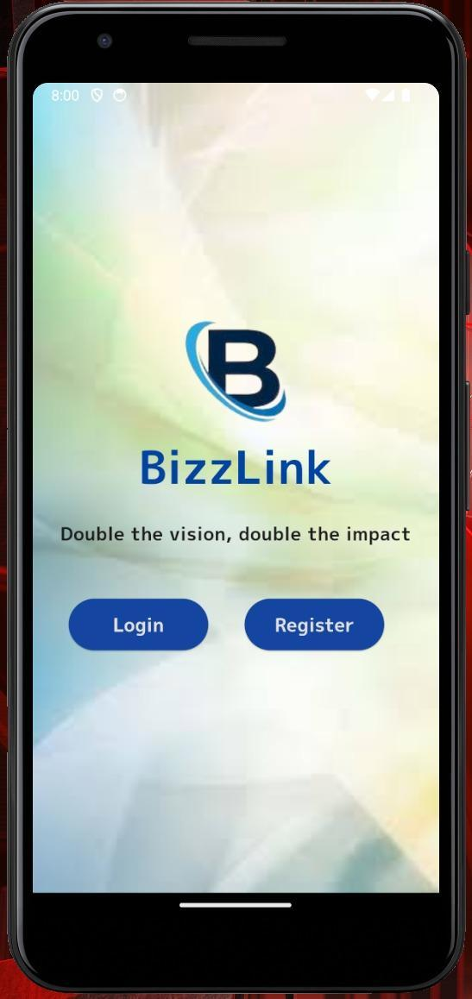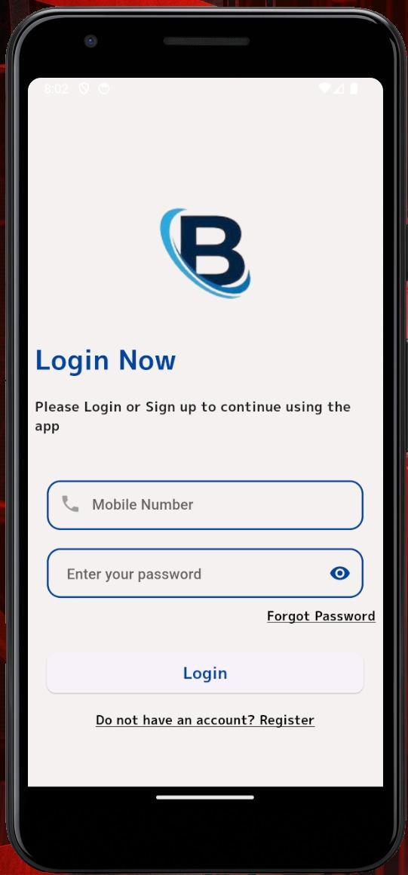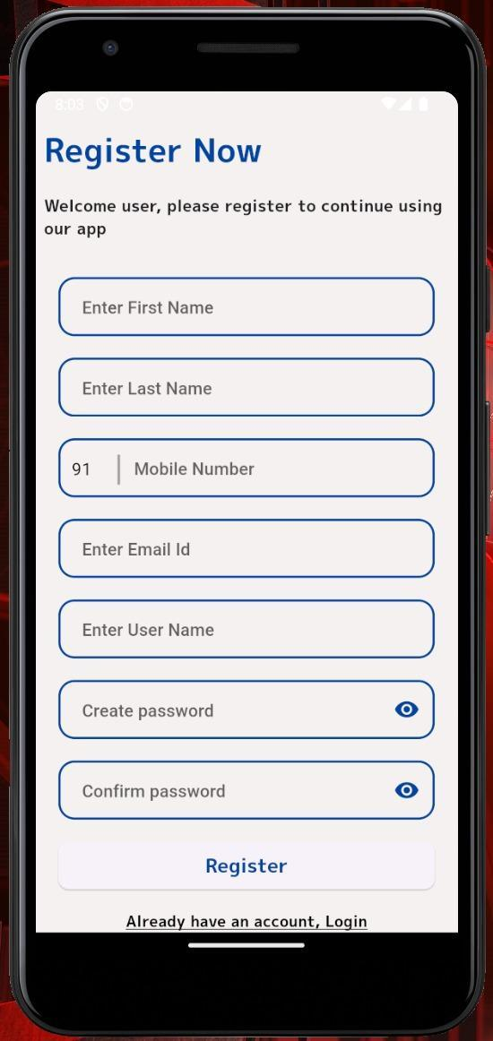

*Figure 1.2 Figure 1.3 Figure 1.4*

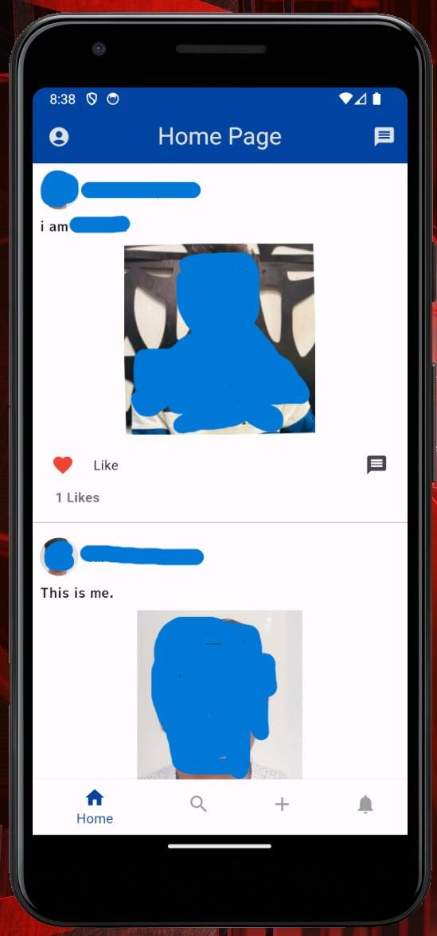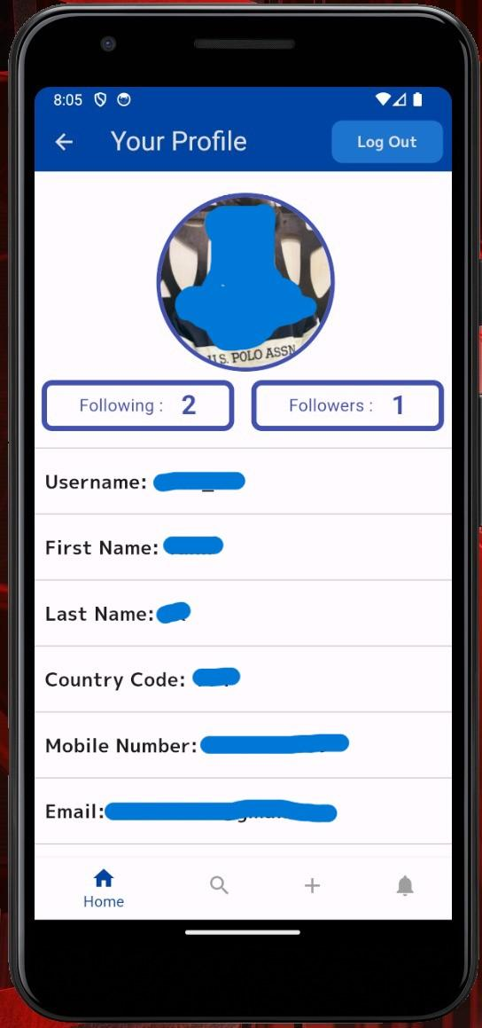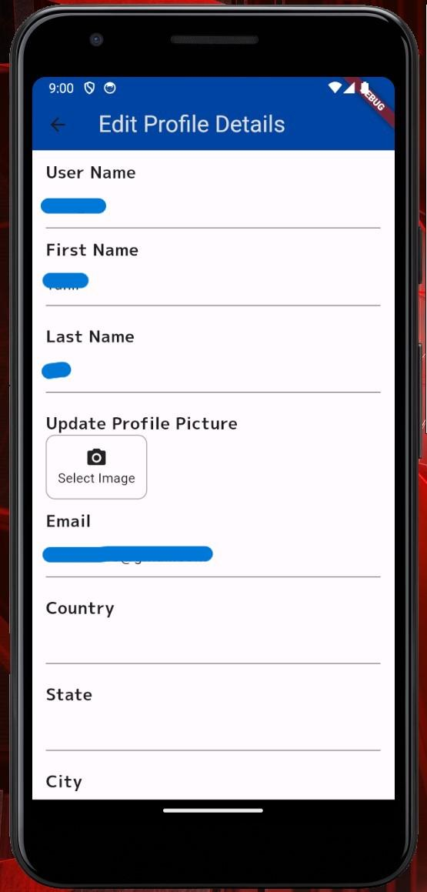

*Figure 1.5 Figure 1.6 Figure 1.7*

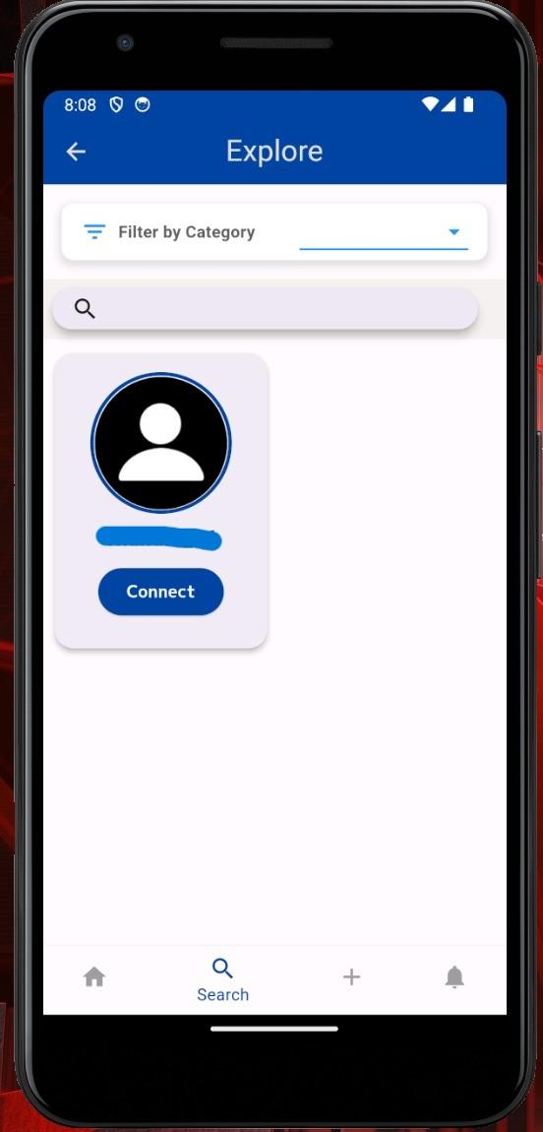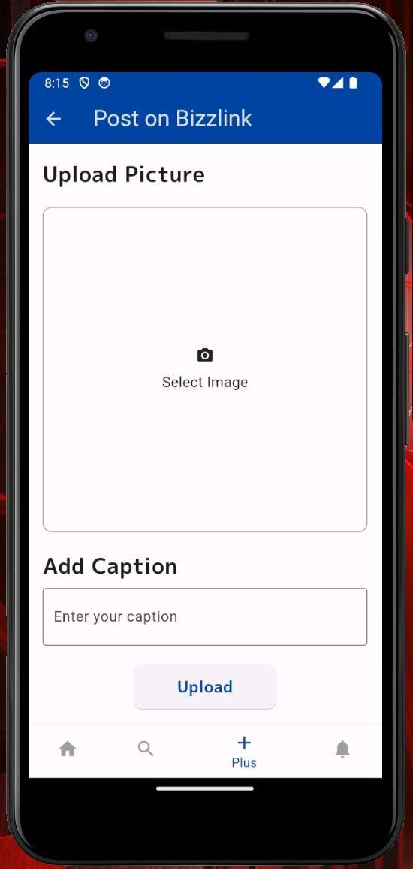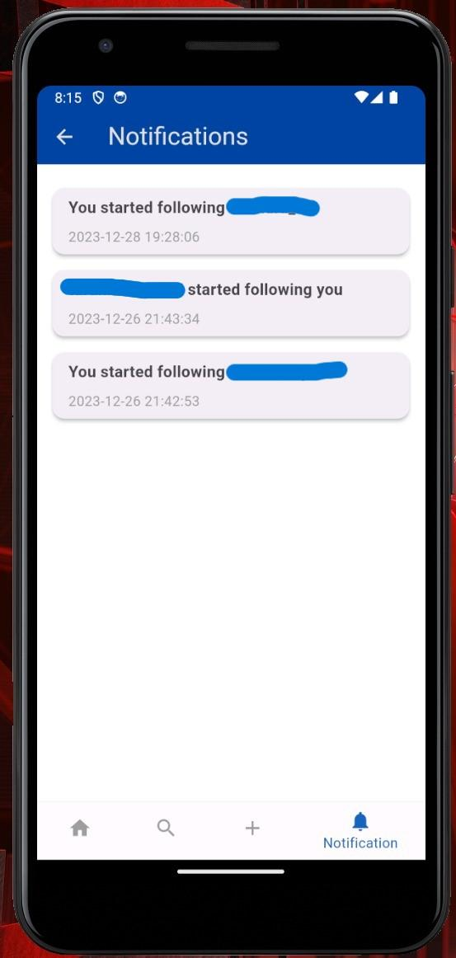

*Figure 1.8 Figure 1.9 Figure 1.10*

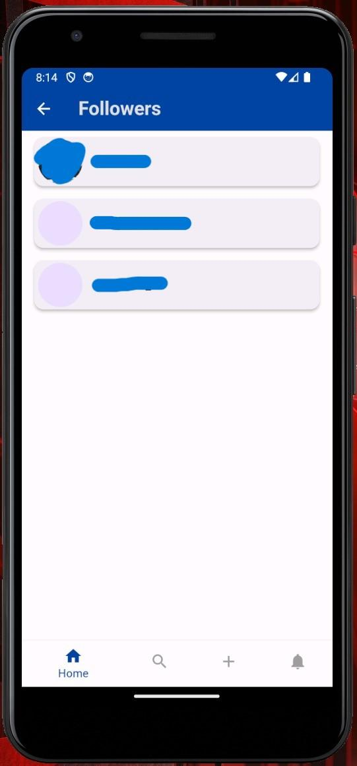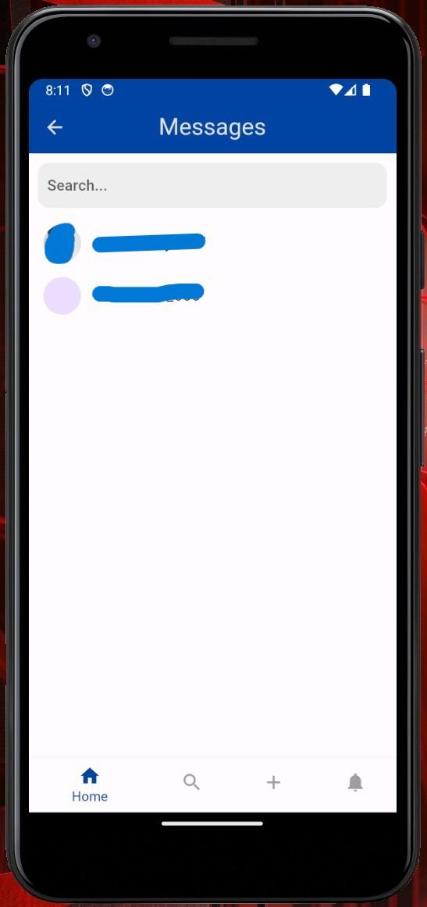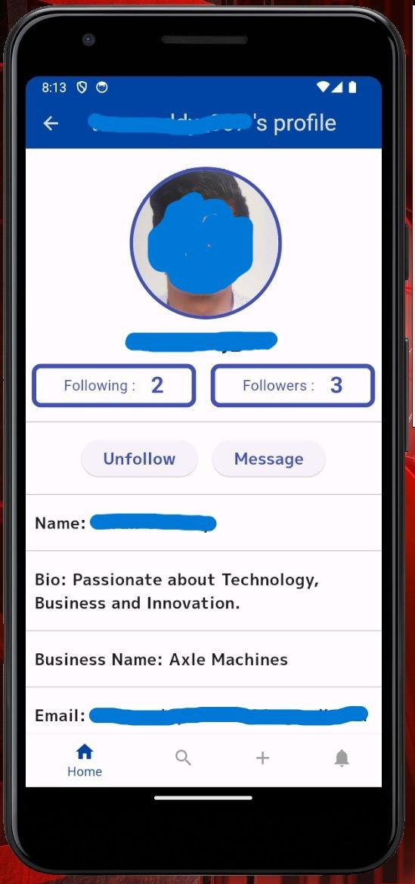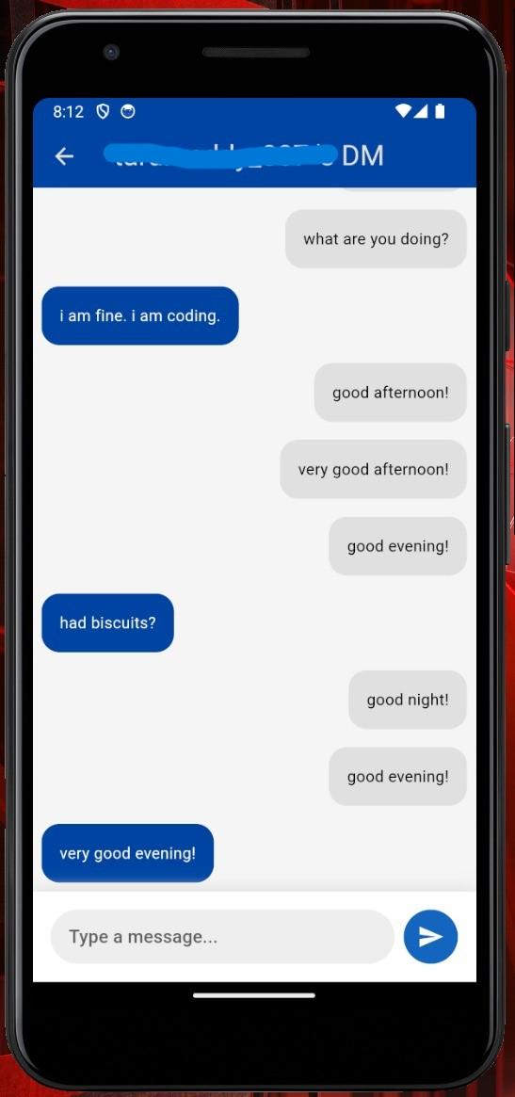

*Figure 1.11 Figure 1.12 Figure 1.13 Figure 1.14*

**APPENDIX-C**

**ENCLOSURES**

**14.1 Plagiarism Report:**



*Figure 1.15*